**Name-Ayan Sadhukhan**

**Regd No-19BEC1448**

***Question 1:***

Write a program to compute the following operations on binary tree

1. Height of a binary tree
2. List of leaf nodes
3. Number of nodes
4. Degree of each node
5. Ancestors of a given node

***Code:***

1. ***Height of a binary tree:***

// C++ program to print inorder traversal

// using stack.

#include<bits/stdc++.h>

using namespace std;

/* A binary tree Node has data, pointer to left child

and a pointer to right child */

struct Node

{

int data;

struct Node* left;

struct Node* right;

Node (int data)

{

this->data = data;

left = right = NULL;

}

};

/* Iterative function for inorder tree

traversal */

void inOrder(struct Node *root)

{

stack<Node *> s;

Node *curr = root;

while (curr != NULL || s.empty() == false)

{

/* Reach the left most Node of the

curr Node */

while (curr != NULL)

{

/* place pointer to a tree node on

the stack before traversing

the node's left subtree */

s.push(curr);

curr = curr->left;

}

/* Current must be NULL at this point */

curr = s.top();

s.pop();

cout << curr->data << " ";

/* we have visited the node and its

left subtree. Now, it's right

subtree's turn */

curr = curr->right;

} /* end of while */

}

int height(Node* root)

{

// Base case: empty tree has height 0

if (root == NULL)

return 0;

// recur for left and right subtree and consider maximum depth

return 1 + max(height(root->left), height(root->right));

}

/* Driver program to test above functions*/

int main()

{

struct Node *root = new Node(1);

root->left = new Node(2);

root->right = new Node(3);

root->left->left = new Node(4);

root->left->right = new Node(5);

inOrder(root);

cout<<"\nThe height of the tree is :"<<height(root)<<endl;

return 0;

}

***Output:***

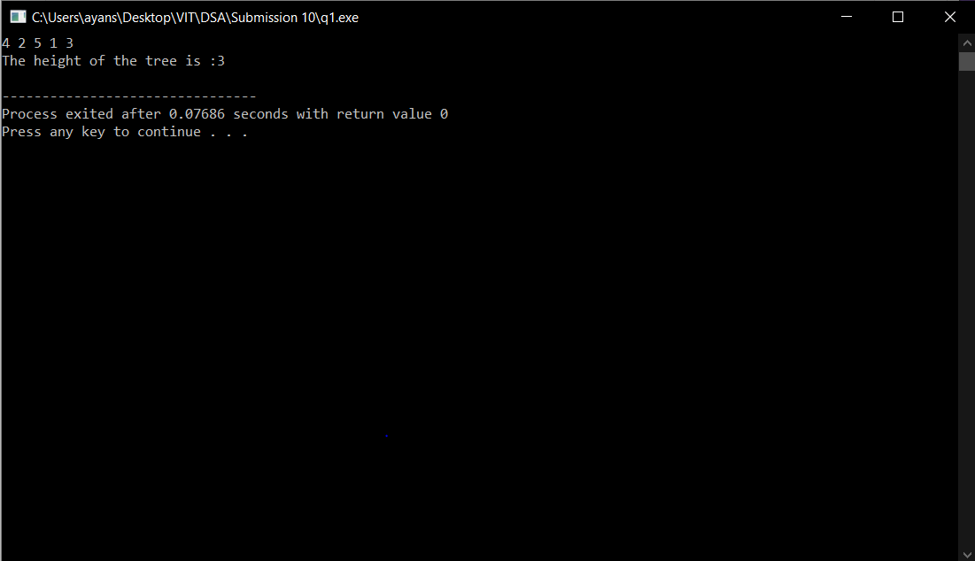

1. List of leaf nodes:

***Code:***

// C++ program to print inorder traversal

// using stack.

#include<bits/stdc++.h>

using namespace std;

/* A binary tree Node has data, pointer to left child

and a pointer to right child */

vector<int> a;

struct Node

{

int data;

struct Node* left;

struct Node* right;

Node (int data)

{

this->data = data;

left = right = NULL;

}

};

/* Iterative function for inorder tree

traversal */

void degree(struct Node *node){

int f=0;

if(node==NULL)

cout<<"degree is 0";

if(node->left!=NULL)

{

f+=1;

}

if(node->right!=NULL)

{

f+=1;

}

//cout<<"\nThe degree is :"<<f<<endl;

if(f==0)

{

a.push_back(node->data);

}

f=0;

//degree(node->left);

//degree(node->right);

//node=node->

}

void inOrder(struct Node *root)

{

stack<Node *> s;

Node *curr = root;

int f=0;

while (curr != NULL || s.empty() == false)

{

/* Reach the left most Node of the

curr Node */

while (curr != NULL)

{

/* place pointer to a tree node on

the stack before traversing

the node's left subtree */

s.push(curr);

curr = curr->left;

f=f+1;

//degree(curr);

}

/* Current must be NULL at this point */

curr = s.top();

s.pop();

cout << curr->data << " ";

degree(curr);

/* we have visited the node and its

left subtree. Now, it's right

subtree's turn */

curr = curr->right;

} /* end of while */

cout<<"\nThe number of nodes in the tree is :";

cout<<f<<endl;

}

struct Node *end(struct Node *root)

{

}

/* Driver program to test above functions*/

int main()

{

struct Node *root = new Node(1);

root->left = new Node(2);

root->right = new Node(3);

root->left->left = new Node(4);

root->left->right = new Node(5);

inOrder(root);

cout<<"The list of leaf nodes are :";

for (int i=0;i<a.size();i++)

{

cout<<a[i]<<" ";

}

cout<<endl;

//degree(curr);

return 0;

}

***Output:***

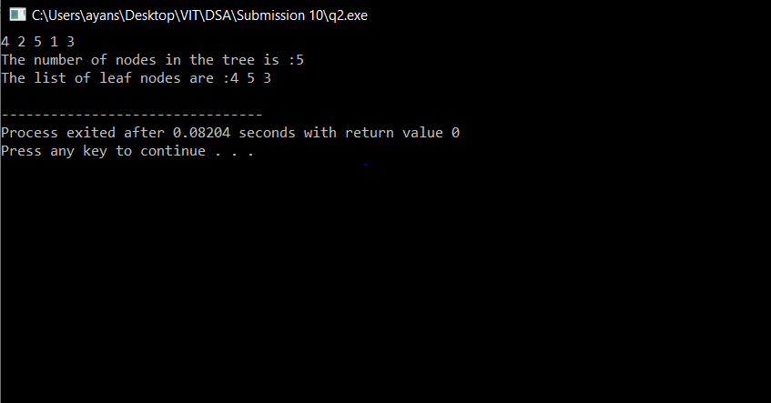

1. Number of nodes

***Code:***

// C++ program to print inorder traversal

// using stack.

#include<bits/stdc++.h>

using namespace std;

/* A binary tree Node has data, pointer to left child

and a pointer to right child */

vector<int> a;

struct Node

{

int data;

struct Node* left;

struct Node* right;

Node (int data)

{

this->data = data;

left = right = NULL;

}

};

/* Iterative function for inorder tree

traversal */

void degree(struct Node *node){

int f=0;

if(node==NULL)

cout<<"degree is 0";

if(node->left!=NULL)

{

f+=1;

}

if(node->right!=NULL)

{

f+=1;

}

//cout<<"\nThe degree is :"<<f<<endl;

if(f==0)

{

a.push_back(node->data);

}

f=0;

//degree(node->left);

//degree(node->right);

//node=node->

}

void inOrder(struct Node *root)

{

stack<Node *> s;

Node *curr = root;

int f=0;

while (curr != NULL || s.empty() == false)

{

/* Reach the left most Node of the

curr Node */

while (curr != NULL)

{

/* place pointer to a tree node on

the stack before traversing

the node's left subtree */

s.push(curr);

curr = curr->left;

f=f+1;

//degree(curr);

}

/* Current must be NULL at this point */

curr = s.top();

s.pop();

cout << curr->data << " ";

degree(curr);

/* we have visited the node and its

left subtree. Now, it's right

subtree's turn */

curr = curr->right;

} /* end of while */

cout<<"\nThe number of nodes in the tree is :";

cout<<f<<endl;

}

struct Node *end(struct Node *root)

{

}

/* Driver program to test above functions*/

int main()

{

struct Node *root = new Node(1);

root->left = new Node(2);

root->right = new Node(3);

root->left->left = new Node(4);

root->left->right = new Node(5);

inOrder(root);

return 0;

}

***Output:***

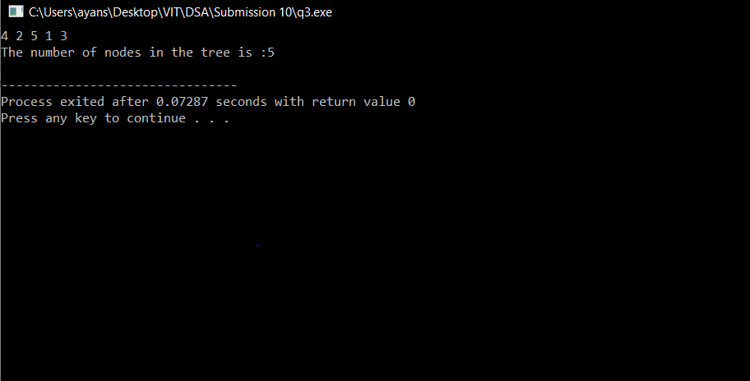

1. Degree of each node

***Code:***

// C++ program to print inorder traversal

// using stack.

#include<bits/stdc++.h>

using namespace std;

/* A binary tree Node has data, pointer to left child

and a pointer to right child */

vector<int> a;

struct Node

{

int data;

struct Node* left;

struct Node* right;

Node (int data)

{

this->data = data;

left = right = NULL;

}

};

/* Iterative function for inorder tree

traversal */

void degree(struct Node *node){

int f=0;

if(node==NULL)

cout<<"degree is 0";

if(node->left!=NULL)

{

f+=1;

}

if(node->right!=NULL)

{

f+=1;

}

cout<<"\nThe degree is :"<<f<<endl;

if(f==0)

{

a.push_back(node->data);

}

f=0;

//degree(node->left);

//degree(node->right);

//node=node->

}

void inOrder(struct Node *root)

{

stack<Node *> s;

Node *curr = root;

int f=0;

while (curr != NULL || s.empty() == false)

{

/* Reach the left most Node of the

curr Node */

while (curr != NULL)

{

/* place pointer to a tree node on

the stack before traversing

the node's left subtree */

s.push(curr);

curr = curr->left;

f=f+1;

//degree(curr);

}

/* Current must be NULL at this point */

curr = s.top();

s.pop();

cout << curr->data << " ";

degree(curr);

/* we have visited the node and its

left subtree. Now, it's right

subtree's turn */

curr = curr->right;

} /* end of while */

//cout<<"\nThe number of nodes in the tree is :";

//cout<<f<<endl;

}

struct Node *end(struct Node *root)

{

}

/* Driver program to test above functions*/

int main()

{

struct Node *root = new Node(1);

root->left = new Node(2);

root->right = new Node(3);

root->left->left = new Node(4);

root->left->right = new Node(5);

inOrder(root);

return 0;

}

***Output:***

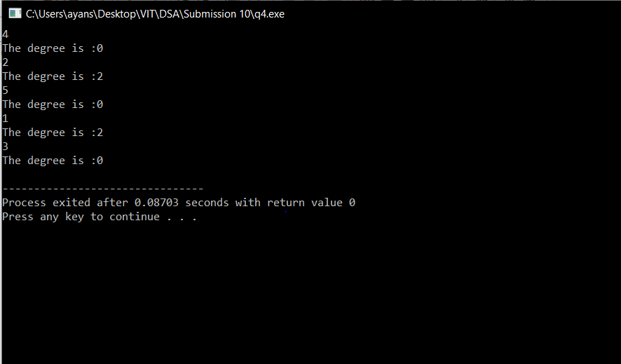

1. Ancestors of a given node

***Code:***

#include<bits/stdc++.h>

using namespace std;

/* A binary tree node has data, pointer to left child

and a pointer to right child */

struct node

{

int data;

struct node* left;

struct node* right;

};

/* If target is present in tree, then prints the ancestors

and returns true, otherwise returns false. */

bool printAncestors(struct node *root, int target)

{

/* base cases */

if (root == NULL)

return false;

if (root->data == target)

return true;

/* If target is present in either left or right subtree of this node,

then print this node */

if ( printAncestors(root->left, target) ||

printAncestors(root->right, target) )

{

cout << root->data << " ";

return true;

}

/* Else return false */

return false;

}

/* Helper function that allocates a new node with the

given data and NULL left and right pointers. */

struct node* newnode(int data)

{

struct node* node = (struct node*)

malloc(sizeof(struct node));

node->data = data;

node->left = NULL;

node->right = NULL;

return(node);

}

void inOrder(struct node *root)

{

stack<node *> s;

node *curr = root;

int f=0;

while (curr != NULL || s.empty() == false)

{

/* Reach the left most Node of the

curr Node */

while (curr != NULL)

{

/* place pointer to a tree node on

the stack before traversing

the node's left subtree */

s.push(curr);

curr = curr->left;

f=f+1;

//degree(curr);

}

/* Current must be NULL at this point */

curr = s.top();

s.pop();

cout << curr->data << " ";

//degree(curr);

/* we have visited the node and its

left subtree. Now, it's right

subtree's turn */

curr = curr->right;

} /* end of while */

//cout<<"\nThe number of nodes in the tree is :";

//cout<<f<<endl;

}

/* Driver program to test above functions*/

int main()

{

struct node *root = newnode(1);

root->left = newnode(2);

root->right = newnode(3);

root->left->left = newnode(4);

root->left->right = newnode(5);

root->left->left->left = newnode(7);

cout<<"The tree is :"<<endl;

inOrder(root);

cout<<"\n The ancestor nodes of node 7 is :";

printAncestors(root, 7);

getchar();

return 0;

}

***Output:***

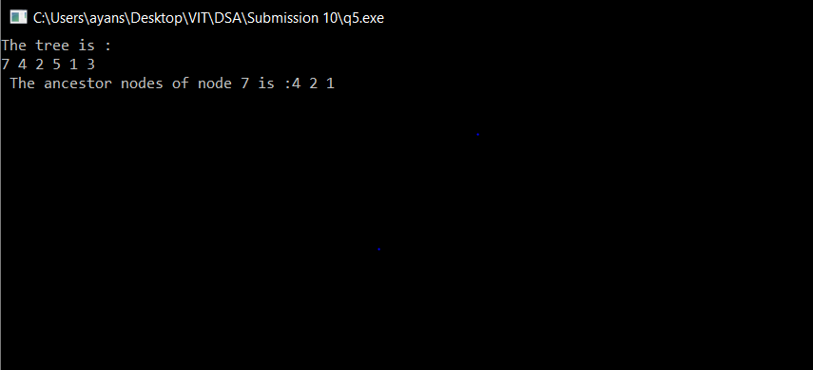

***Question 2:***

A full node is a node with two children. Write a program to compute all full nodes in the given binary tree.

***Code:***

#include <bits/stdc++.h>

using namespace std;

struct Node

{

int data;

struct Node* left, *right;

};

unsigned int getfullCount(struct Node* root)

{

if (root == NULL)

return 0;

int res = 0;

if (root->left && root->right)

res++;

res += (getfullCount(root->left) +

getfullCount(root->right));

return res;

}

struct Node* newNode(int data)

{

struct Node* node = new Node;

node->data = data;

node->left = node->right = NULL;

return (node);

}

void inOrder(struct Node *root)

{

stack<Node *> s;

Node *curr = root;

int f=0;

while (curr != NULL || s.empty() == false)

{

while (curr != NULL)

{

s.push(curr);

curr = curr->left;

f=f+1;

}

curr = s.top();

s.pop();

cout << curr->data << " ";

curr = curr->right;

}

cout<<"\nThe number of nodes in the tree is :";

cout<<f<<endl;

}

// Driver program

int main(void)

{

struct Node *root = newNode(2);

root->left = newNode(7);

root->right = newNode(5);

root->left->right = newNode(6);

root->left->right->left = newNode(1);

root->left->right->right = newNode(11);

root->right->right = newNode(9);

root->right->right->left = newNode(4);

inOrder(root);

cout <<"The total number of full nodes in a binary tree is :"<< getfullCount(root);

return 0;

}

***Output:***

